Exposed Services
TODO: Fill out the information below.
Nmap scan results for each machine reveal the below services and OS details:
$ nmap -sS 192.168.1.0/24
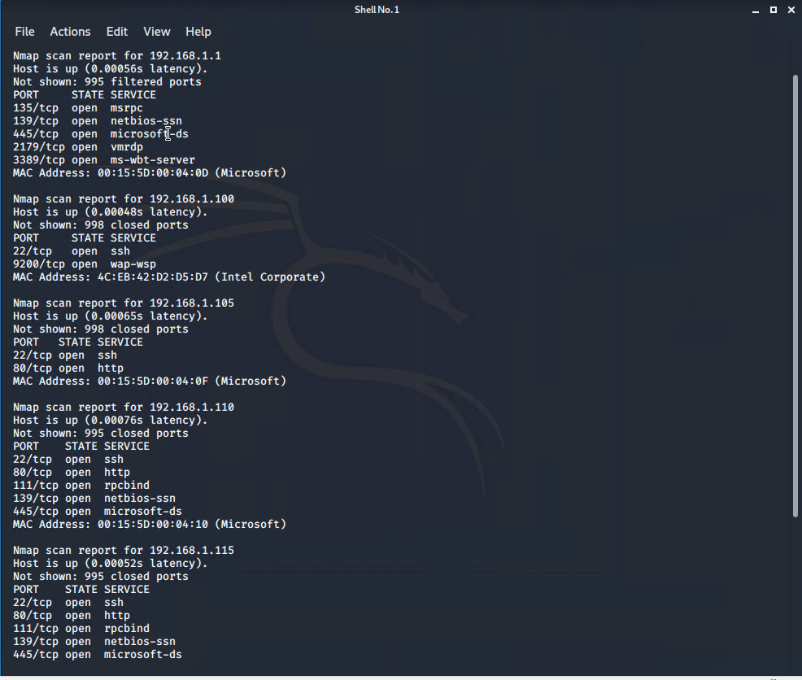
This scan identifies the services below as potential points of entry:
- Target 1
  - http port 80
  - ssh port 22
  - rpcbind port 111
  - netbios-ssn port 139
  - microsoft-ds port 445
The following vulnerabilities were identified on each target:
- Target 1
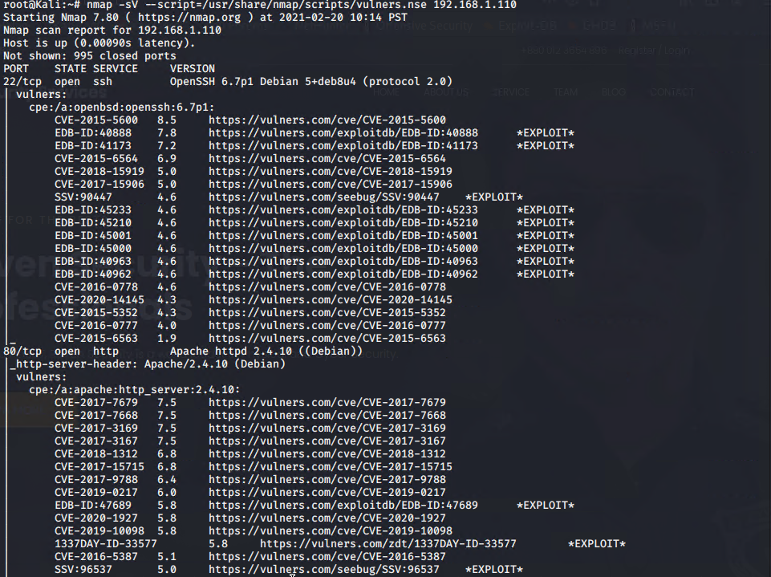
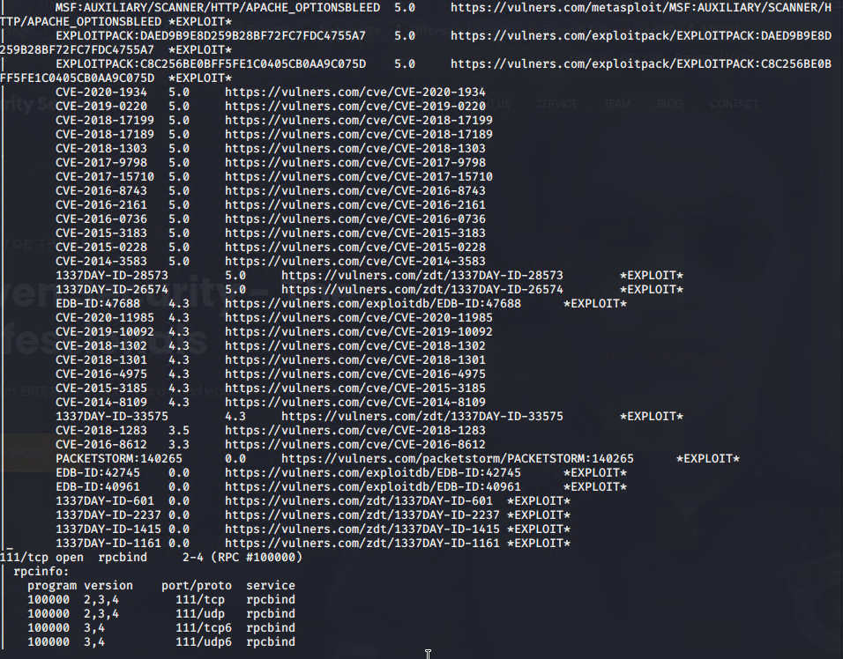
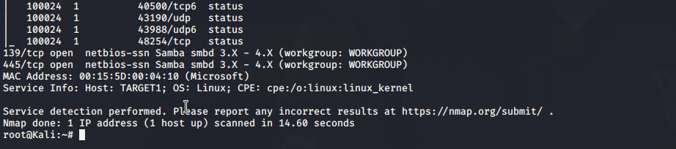

Exploitation
TODO: Fill out the details below. Include screenshots where possible.
The Red Team was able to penetrate Target 1 and retrieve the following confidential data:
- Target 1
  - flag1.txt: b9bbcb33e11b80be759c4e844862482d
    - Exploit Used
      - ssh into Michael’s account using password “michael”
      - Moved into var/www/html and ran ‘grep -i ‘flag’ *filename*’ until finding a line in one of the html files with the flag
  - flag2.txt: fc3fd58dcdad9ab23faca6e9a36e581c
    - Exploit Used
      - ssh into Michael’s account using password “michael”
      - Used commane ‘find / -iname *flag*’ and parsed results
  - flag3: afc01ab56b50591e7dccf93122770cd2
    - Exploit Used
      - Found MySQL database information in Michael’s account
      - Logged into MySQL and searched the wordpress database until I found the table with flag 3 which was wp_posts
  - flag4: 715dea6c055b9fe3337544932f2941ce
    - Exploit Used
      - After cracking steven’s password and gaining an ssh session I ran ‘sudo -l’ and saw I had python root privilege
      - I then ran ‘sudo python -c ‘import pty;pty.spawn(“/bin/bash”)’’ to gain root
      - After a simple ‘find / -iname *flag*’ I found flag 4

